Boating license and ICC
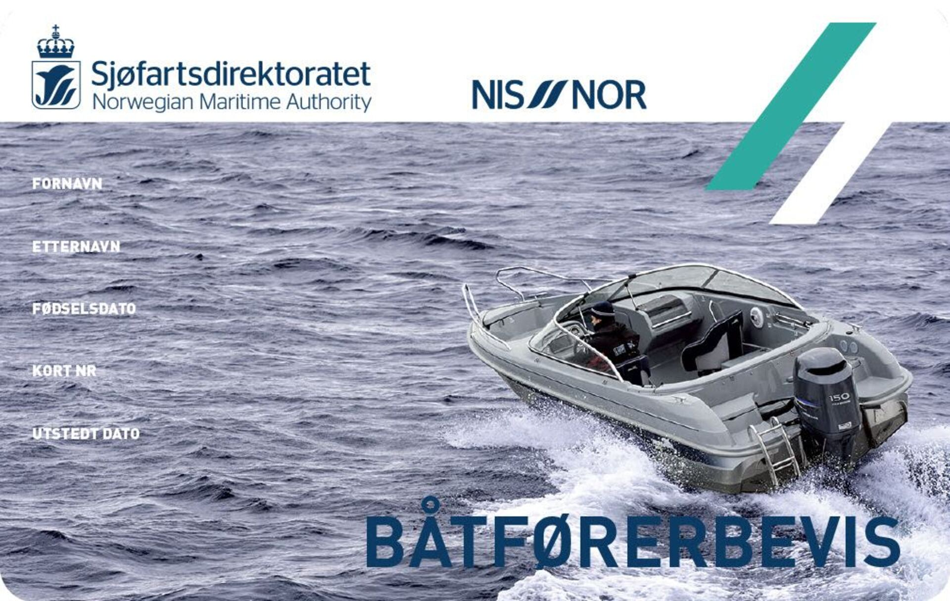
Boating License Regulations
In Norway, there is a requirement for a boat driver's license to drive a recreational boat. If you were born 01.01.1980 or later, and are going to drive a boat with more than 25 hp or more than 8 meters in length, you need a boat driving licence. People who were born earlier than 01.01.1980, are also encouraged to take the test in order to contribute to the safety and security of everyone who travels at sea.
Is my foreign boat driver's license valid in Norway? The answer to this is, Yes!
Detailed information about the boat driver's test/boat driver's license/foreign boat driver's license can be found by clicking here

