Fishing tips
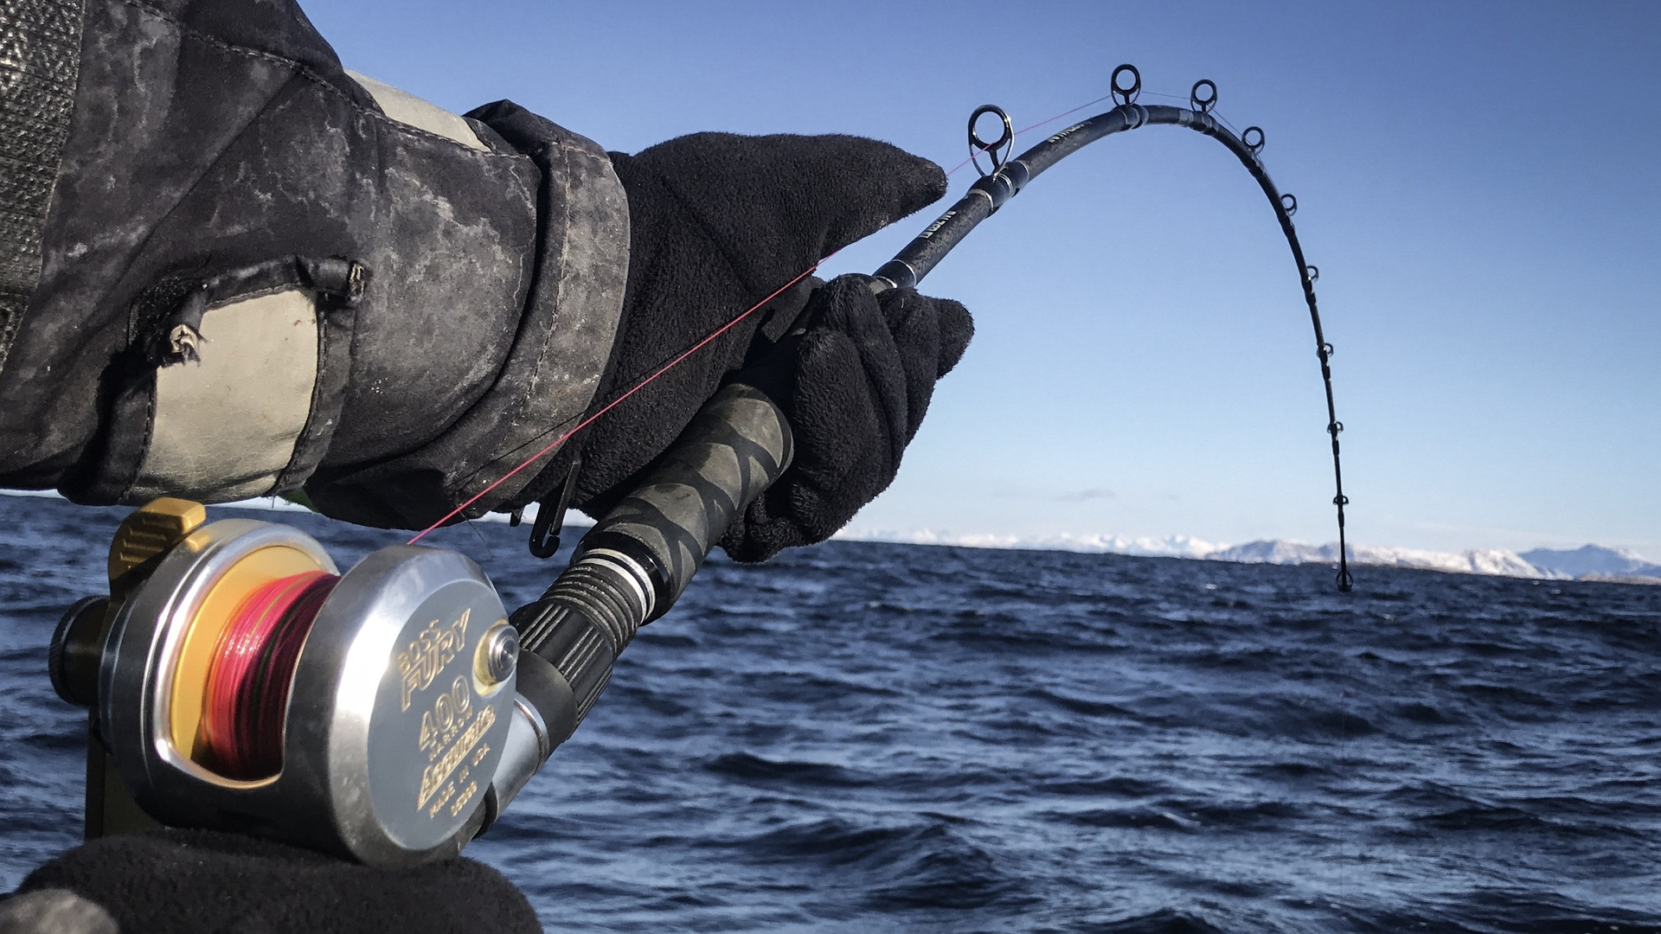

Sandsøy Fishing Adventure fishing tips
When you book your fishing trip with Sandsøy Fishing Adventure AS you are guaranteed a high standard of accommodation and boats, in a prime location for the best fishing spots. We have already done this work for you! But we have saved the best and most exciting job for you - namely, catching the fish of your dreams yourself.
At Sandsøy Fishing Adventure As we try everything to make your fishing dream come true, but it also requires that you as an angler are well prepared. To be successful, you should inform yourself well in advance about regulations, species, minimum sizes, fishing gear and fishing methods. However, what is almost more important is a good dose of patience and perseverance. Local knowledge is also a very important factor and our hosts have it. Your host will be able to answer most of your questions and will be happy to help.
There is a lot of information when it comes to choosing the right equipment and technique. Therefore, we would like to share some of our tips and experiences with you.
We hope that our information will be useful and helpful in your preparations for your next fishing holiday with Din Tur in Norway.

Correct choice of rod and reel
ALL ROUND GEAR: Unfortunately, there are limits to the number of fishing rods you can take with you on your trip. So, if you are only going to be using one rod we would recommend a medium sea fishing rod, 6-8 feet long and around 20-30 lbs action. This is a sufficient choice in most cases.
LIGHT EQUIPMENT: For the more experienced and avid fisherman, we recommend a light rod with a length of 2.15-2.40 meters and a casting weight of around 80-200 gr. A reel of size 4000-5000 or 250-300 meters of multifilament line with a breaking strain of 10 to 20 kg. This is similar to PE class 1.7 - 2.0. These can withstand a light casting weight of up to 200 grams and are well suited for fishing up to approx. 10 - 60 meters.
HEAVY TACKLE: Rods from 6-8 feet with an action of around 30-50 pounds. These require a reel with a gear ratio that makes it easy to reel in the bait from the deep. The reel should have a capacity of up to 400 meters of multifilament with a breaking load of 25 - 30 kg per kg in PE class 3-4. You can fish well up to 300 meters deep with it and you can use up to 1 kg of lead on deep-sea fishing.
REEL: Sea fishing reels (multiple reels) in size 10-25 are in trend today, these take up approx. 300-400 meters of multifilament in the PE class 1.5 - 3.5 with a load capacity of up to 18-30 kg. This equipment is well suited for fishing to depths of 100 meters with jigs and shads weighing up to 400 grams.

Multiplier reel for deep sea fishing
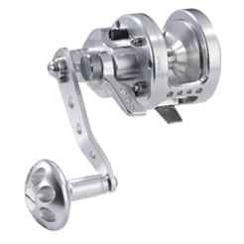 Casting reel
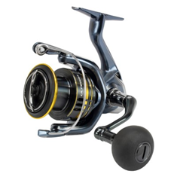

Jigging and deep sea fishing rod for multiplier

Casting rod
Which line should I use?

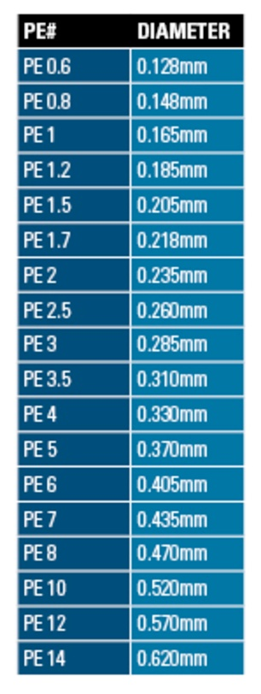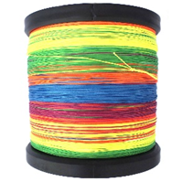
Multifilament line (braided line): is the best choice for deep water with a strong current, multifilament line is the only thing that is well suited for sea fishing in Norway, these lines are thin and without stretch, so you have very good contact with the bait.
Some lines are marked with different colors that change every 10 meters to help you find the fish. Lines of 0.20-0.30 mm are recommended here. A larger diameter means more pressure and flow in the line, and this makes fishing with lighter weights more difficult.
Many manufacturers of multifilament’s specify their line in the so-called PE class.
braided line in different colors change every 10 meters

FISHING GEAR
In shallow water we use pilkers with different colours. In depths over 30 m compact pilkers with some luminescent materials are a good choice. Depending on the depth and current, you should use a pilker that is as light as possible. If you want to increase your chances of catching as many fish as possible, you can use a “gummimakk” which is a hook with small red silicon tubes of different sizes. For codfish, coalfish and pollack we recommend the size 8/0 - 10/0 in red colour for the best catch. If you're fishing for redfish, then the best colour is red and hook size 8/0 – 10/0.

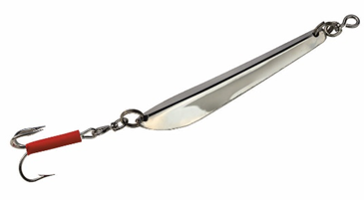T 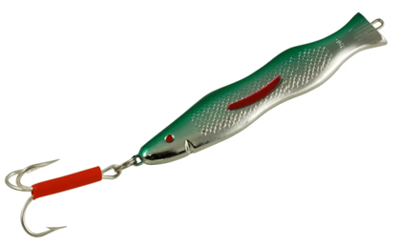 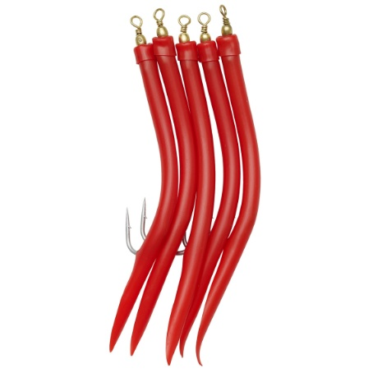
Traditional pilk Standard pilk “Gummimakk”

Rubber fish
In last year’s there has been a growing trend towards rubber fish, especially when fishing for halibut, big coalfish and cod. Here you fish much more selectively than any pilker. With rubber fish you can vary colour, size and weight. We recommend smaller weights of 40-100 g for fishing for pollock and coalfish. And rubber fish of 10-15 cm. When it comes to cod and halibut, it can be a little bigger. Rubbers of 20-30 cm in weights of 150-400 g are often used here.

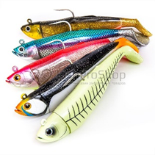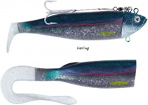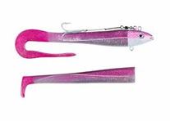

Deep sea fishing and riggs
In Norway, bait fishing by rod and reel is not common among the local population. Therefore, take with you everything that you need for deep fishing on your fishing trip. For deep-sea fishing for redfish, ling, wolffish you need lead weights of 300 - 800 gr. If you don't want to weigh yourself down on the flight, you can buy these weights in almost all shops in Norway.

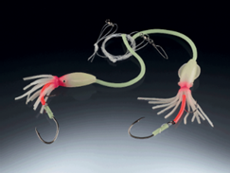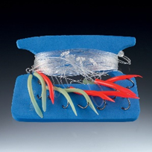

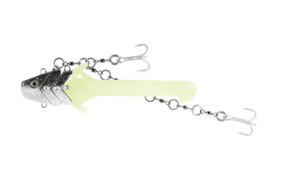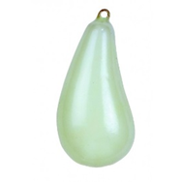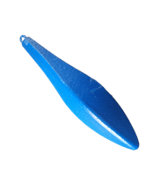

Landing gear
There are different versions of landing gear, the most common is probably the gaff-hook, which is available in different lengths and strengths. Large shark hooks or rope loops are also often used when fishing for halibut to land the fish safely. All of these devices can be found in all sports shops and discounters.
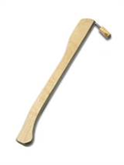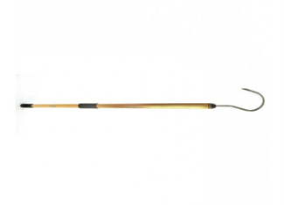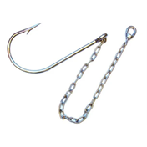
Knife and pliers
It is also important that you always have a sharp knife on board, which is primarily required for fish care, but can also be vital in other situations. You should also always have good pliers with you to loosen any deep-seated hooks in the fish.
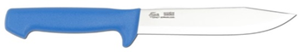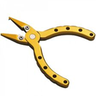

It is also advisable to have a fighting belt with you to protect your soft tissues from bruises.
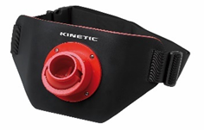

Baits

Practical fishing tips
A very important factor in sea fishing is the HIGH and LOW TIDE. The tides often have a very crucial impact on success or failure. The conditions at the various fishing spots often change with the tide and where there was little activity before, the fjord suddenly boils and the fish are active.
When approaching the fishing spot, it is important to make sure you know which direction the wind is blowing from, so you can determine how you want to fish the spot. Most places are fished by drifting from shallow to deep water, avoiding getting stuck on the bottom and damaging your line.
There are different methods of hunting the fish, a traditional way is the classic fishing with a pliker.
When jigging, you let the pilker down to the bottom and move it up and down over the bottom or in higher water layers where you expect the fish to be. This method is very effective for cod, pollock, coalfish and haddock. Some anglers also garnish the pilker with a piece of fish, which is very successful on most bottom fish species such as ling or redfish.
When fishing for coalfish, you can reel it in as quickly as possible until you get contact with fish. When you are fishing for halibut reel the bait slowly from the bottom to the surface, making short stops in between. It is important that you move the bait constantly and avoid large movements as the halibut will follow the bait for a long time before attacking.
Another very popular method is fishing with natural bait, here there are also many different variants such as special target fish leaders for redfish, ling or wolffish. Here the single hooks are equipped with filet and placed over the bottom. Redfish riggs are usually equipped with several single hooks and the distance between the hooks is wider than with other fish species. The advantage of the length of the leader is that you search the water layers faster and more effciently. Redfish often stand up to 20-40 meters above the bottom.
If you follow all of these tips, nothing stands in the way of you catching the fish of your dreams.

Tight lines

